Chapter 17, Solution 70.

Design a problem to help other students to better understand how to use PSpice to solve circuit problems with periodic inputs.

Although there are many ways to solve this problem, this is an example based on the same kind of problem asked in the third edition.

Problem

Rework Prob. 17.40 using PSpice.

Chapter 17, Problem 40.

The signal in Fig. 17.77(a) is applied to the circuit in Fig. 17.77(b). Find v_{o}(t).

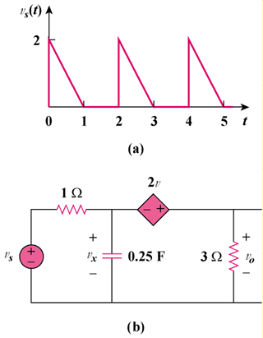

Figure 17.77

Solution

The schematic is shown below. In the Transient dialog box, we set Print Step = 0.02 s, Final Step = 12 s, Center Frequency = 0.5, Output Vars = V(1) and V(2), and click enable Fourier. After simulation, we compare the output and output waveforms as shown. The output includes the following Fourier components.

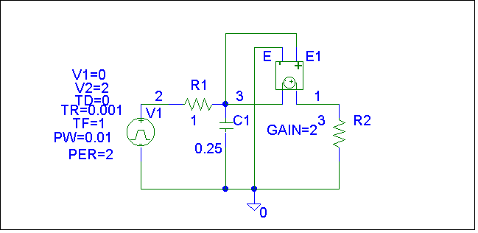
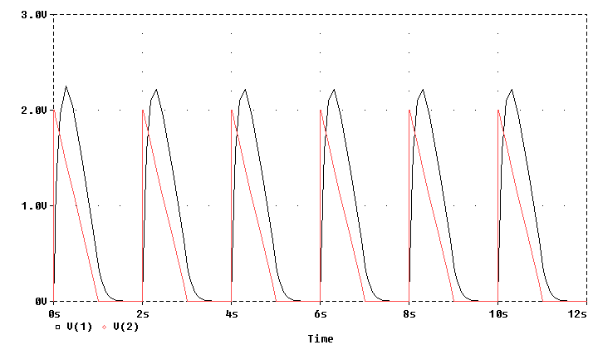

FOURIER COMPONENTS OF TRANSIENT RESPONSE V(1)

DC COMPONENT = 7.658051E-01

HARMONIC FREQUENCY FOURIER NORMALIZED PHASE NORMALIZED
NO (HZ) COMPONENT COMPONENT (DEG) PHASE (DEG)

1 5.000E-01 1.070E+00 1.000E+00 1.004E+01 0.000E+00
2 1.000E+00 3.758E-01 3.512E-01 -3.924E+01 -4.928E+01
3 1.500E+00 2.111E-01 1.973E-01 -3.985E+01 -4.990E+01
4 2.000E+00 1.247E-01 1.166E-01 -5.870E+01 -6.874E+01
5 2.500E+00 8.538E-02 7.980E-02 -5.680E+01 -6.685E+01
6 3.000E+00 6.139E-02 5.738E-02 -6.563E+01 -7.567E+01
7 3.500E+00 4.743E-02 4.433E-02 -6.520E+01 -7.524E+01
8 4.000E+00 3.711E-02 3.469E-02 -7.222E+01 -8.226E+01
9 4.500E+00 2.997E-02 2.802E-02 -7.088E+01 -8.092E+01

TOTAL HARMONIC DISTORTION = 4.352895E+01 PERCENT

